**Comparison of fitting functions for categorical loudness scaling data**

Dirk Oetting1, Ray Meddis2, Stephan D. Ewert3

1Fraunhofer IDMT, Hearing, Speech and Audio Technology, Oldenburg

2University of Essex, Colchester

3Medizinische Physik, Universität Oldenburg

Schlüsselwörter: Lautheitsskalierung, loudness scaling, ACALOS, Lautheitsfunktion, Hörgeräteanpassung

Introduction

Adaptive categorical loudness scaling (ACALOS; Brand and Hohmann, 2002) quantifies loudness perception for stimuli of different levels on a scale ranging from inaudible, through soft, and comfortable to too loud. Although the measurement procedure was standardized in ISO (2006), the benefits in diagnosis and particularly hearing-aid fitting could be improved. In (Herzke and Hohmann, 2005) individual loudness functions were used to adjust a dynamic compressor to the hearing loss. Recently, in (Kreikemeier *et al*., 2011) the measurement of hearing threshold, comfortable and uncomfortable levels by ACALOS was used for hearing-aid gain prescription. Typically, this process uses the ACALOS-specific model function relating categorical units (CU) to stimulus level based on the raw data. Here, it is shown that the model function and the fitting procedure have a strong impact on the interpretation and use of ACALOS data. The standard fitting model for loudness scaling procedures as suggested in (Brand and Hohmann, 2002) is compared with an alternative approach specifically suited for loudness-based, hearing-aid gain prescription.

Material and Method

Loudness scaling data were obtained by the ACALOS procedure in 13 normal-hearing (NH) listeners and 11 hearing-impaired (HI) listeners. Measurements were made in a sound-proof booth using Sennheiser HDA200 circumaural headphones. The scaling procedure was repeated four times on two different days in order to investigate the precision of the procedure. The NH group was aged between 21 and 65 years (mean: 29.2 years, standard deviation: 5.2 years) and had audiometric thresholds of 20 dB HL or better at the test frequencies of 500, 2000, and 6000 Hz (ANSI, 2004). The HI group was aged between 25 and 73 years (mean: 60.5 years, standard deviation: 18.0 years) with mild-to-moderate sensorineural hearing losses (PTA of 18.3 - 55.0 dB). Subjects received an hourly compensation for taking part in the study.

Three different model functions were applied to the ACALOS data at 2000 Hz and differences were analyzed in terms of fitting errors and prediction of the uncomfortable and hearing threshold.

1. Bezier(y): Reference model function of (Brand and Hohmann, 2002). It consists of two linear parts and a (Bezier) transition region between 15 and 35 CU. A least-squares fit is performed in the y-direction (on the CU scale). Parameters to describe the function are the slopes of the linear functions (mlow, mhigh) and the juncture of these lines (Lcut) on the dB scale. The juncture occurs at fixed CU value of 25 (i.e. medium loudness).
2. Bezier(x): Same function as in Bezier(y) except that the least-squares fit is performed in the direction of presentation level (x-direction). The same parameters are used to describe the model function as above.
3. SQ(x) (Stick Quadratic): Alternative model function consisting of a linear function smoothly joins into a quadratic function. Parameters to describe the function are the presentation level for CU = 0, which can be interpreted as the hearing threshold level (HTL), the slope of the linear function (mlow), the connection point (CP) on the CU scale and the estimated level for CU = 50, which can be interpreted as the uncomfortable level (UCL). The range for the CP is limited from 20 to 30 CU. The least-squares fitting was performed over the presentation levels (x-direction).

Minimizing the fitting error in either x- or y-direction raises the question of the underlying application. Assume we want to predict the corresponding CU value for a given level; in this case one should minimize in y-direction (CU scale) so that the prediction error of the CU value is minimized. On the other hand, for hearing-aid fitting we might ask what level corresponds to a given CU value in a NH or HI listener. Accordingly, the error in x-direction (dB scale) should be minimized.

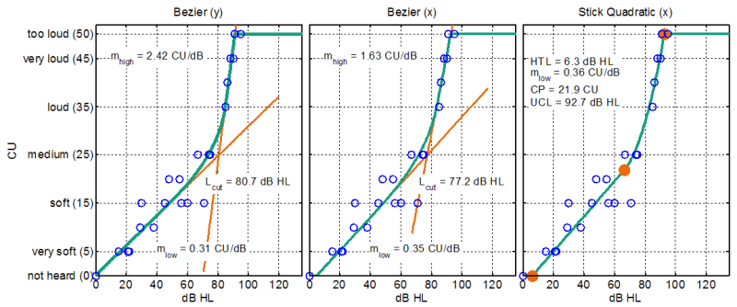

Figure 1: Examples of the three different ACALOS model functions for the same data set and their respective best fitting parameters.

Fig. 1 shows an example data set with the three fitted model functions. The blue circles indicate the CU responses of the subject at a number of presentation levels. The red lines in the left and middle panel indicate the underlying linear functions for Bezier(y) and Bezier(x). The red circles in the right panel indicate the parameters of the Stick Quadratic, SQ(x), model. Bezier(y) and Bezier(x) functions generate similar values for mlow and Lcut while the values for mhigh are considerably different. All three fitting model functions look quite similar, indicating that the quite different parameter mhigh provides little information for further interpretations. The parameters for SQ(x) are more intuitive. They indicate a hearing threshold of 6 dB HL and an uncomfortable level of 93 dB HL. The estimated slope of the linear function in SQ(x) is very close to mlow of Bezier(x). Bezier(y) results in a slightly lower slope for mlow.

Analysis of the ACALOS model functions

First, errors in x- and y-direction were analyzed for the NH and HI group. The deviations between data points and model function were calculated and summed. The deviations in y-direction (CU) were calculated from data in 10 dB intervals. Results are shown in Fig. 2 for the NH and HI group. The summed deviations are indicated by the orange bars, grey circles are the data, and the green lines are the estimated model functions. The root-of-sum of the squared summed deviations for the x- and y-direction are indicated in the figure, denoted as errors. Generally, errors are larger for the NH listeners than for the HI listener. Bezier(x) for NH (top row, left) shows large and biased summed deviations in x-direction in the lower part of the categorical scale. Theses deviations disappear in HI listeners (lower row, left).

For Bezier(x) the error in x-direction for NH (top row, middle) is reduced and errors in y-direction are only slightly higher than for Bezier(y). Differences in the size of the errors between Bezier(x) and SQ(x) are minor.

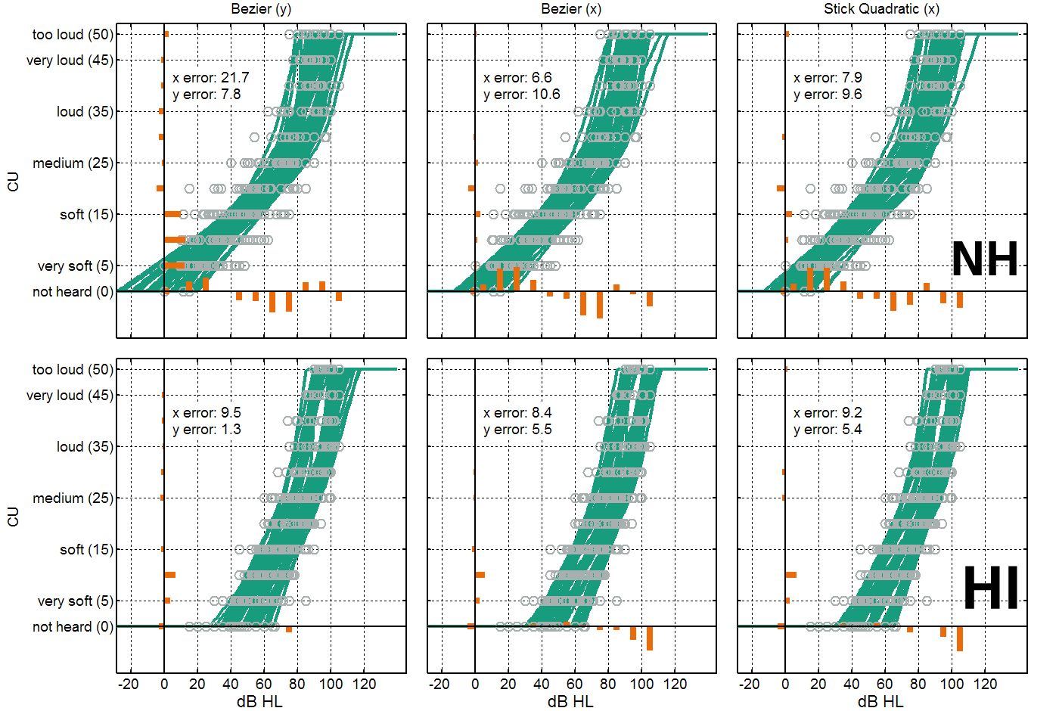

Figure 2: Summed deviations and overall error for the three model functions. Upper row: normal-hearing listeners, lower row: hearing impaired listeners.

Figure 3 shows a comparison of the hearing threshold estimates derived from the model functions at CU = 0 and the audiometric thresholds. It should be mentioned that the loudness scaling was performed with narrow-band noise and the thresholds were measured with pure tones. The median of the estimated thresholds by the reference model, Bezier(y), is -8.2 dB below the audiometric threshold for NH listeners. The median values for NH listeners for Bezier(x) and SQ(x) are -4.9 dB and -4.0 dB, respectively. Values for HI listeners are quite similar across all models at around -10 dB below pure-tone thresholds.

plot136000

Figure 3: Differences between the audiometric thresholds and the estimated thresholds of ACALOS using different loudness functions.

The third test of the model functions was fitting to data sets where we removed all data points above 30 CU (from “loud” to “too loud”). Such data sets sometimes occur due to the limited maximal output levels and can cause misleading model functions. To analyze the robustness of the model functions, the difference between the estimation for CU = 50 (UCL) for the fitting with all data points and with only the remaining data points was calculated and is given in Fig. 3. Only data sets with at least 4 responses above 40 CU were used. Bezier(y) shows the largest interquartile range of differences. It ranges from -6.2 dB to 27.4 dB overestimation of the UCL. Using Bezier(x) reduces the range considerably to -12.1 dB to 7.1 dB. The narrowest range is produced using SQ(x) with an interquartile range of -9.5 dB and -0.9 dB. To compensate the large errors of the standard model Bezier(y), (Brand, 2007) suggested estimating the UCL from the hearing threshold using data from (Pascoe, 1988), if the fitted upper slope (mhigh) is below 0.25 dB/CU or less than 4 data points above 30 CU are given. Results by using this modification are marked with “+ Pascoe” and the interquartile range is 2.0 dB to 9.4 dB.

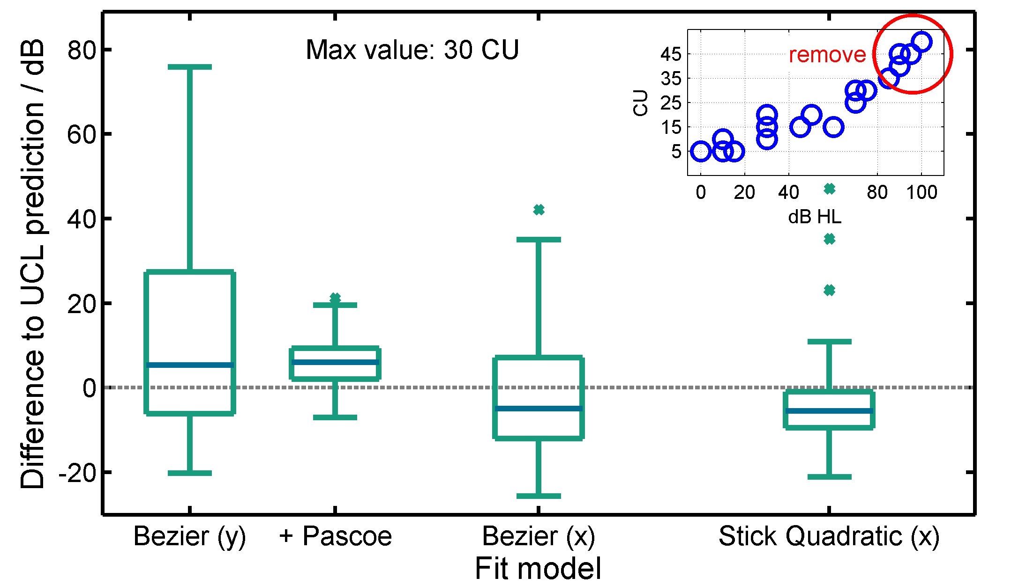

Figure 4: Robustness-test of fitting function against missing values above “loud” which is a common appearance using ACALOS in clinics.

Conclusion

We have analyzed data of adaptive categorical loudness scaling for NH and HI subjects and tested three different loudness functions for fitting the data. Minimizing errors in x-direction leads to an overall lower fitting error, improves estimation of hearing thresholds and reduces systematical errors between NH and HI listeners. The suggested SQ(x) model function is more robust against missing responses in the upper loudness range and the prediction of UCL is improved. Parameters of SQ(x) are also more intuitive (HTL, UCL) which helps interpreting the data. This work was supported by the BMBF ("Modellbasiertes Hörgerät").

Literature

ANSI (American National Standards Institute) (2004) Specification for audiometers. (S3.6 2004), New York

Brand T & Hohmann V (2002) An adaptive procedure for categorical loudness scaling. J Acoust Soc Am, 2002, 112, 1597

Brand T (2007) Loudness Scaling, 8th EFAS Congress, Heidelberg

Herzke T & Hohmann V (2005) Effects of instantaneous multiband dynamic compression on speech intelligibility, EURASIP journal on applied signal processing, 3034-3043

ISO 16832 (2006) Acoustics – Loudness scaling by means of categories.

Kreikemeier S, Latzel M, Kießling J (2011) Loudness-based Hearing Aid Fitting with Instantaneous Insitu-Percentile Monitoring, Z Audiol 50, 62-72

Pascoe DP (1988) Clinical measurements of the auditory dynamic range and their relation to formulas for hearing aid gain. In: J.H. Jensen (Editor) Hearing Aid fitting. 13th Danavox Symposium, 129-152.